JavaScript Curriculum: Student Assignments & Capstone Project
Comprehensive Practical Exercises & Final Project Guide
Intern Details
Intern Name | Vidavaluru Divyanjali
Phone | 9392607501
Institution | Christ University, Main Campus, Bangalore
Email | vidavalurudivyanjali@gmail.com

―――――――――――――――――――――――――――――――――――――――――――――――――――――――
📋 Detailed Student Assignments
The following practical assignments cover the core modules of the JavaScript curriculum. Each assignment outlines a specific task accompanied by its exact expected output.
Assignment 1: Variables, Data Types, and Console Operations
Task: Declare variables using var, let, and const to store a user's name, age, employment status, and a list of skills. Use typeof to check each variable's type and log them to the console.
Expected Output:
Name: Alice (Type: string)
Age: 25 (Type: number)
Is Employed: true (Type: boolean)
Skills: ["HTML", "CSS", "JavaScript"] (Type: object)

Assignment 2: Operators, Expressions, and Input Handling
Task: Use prompt() to capture a user's bill amount and tip percentage. Perform explicit type conversion (e.g., using Number()), compute the total using arithmetic and assignment operators, and log a formatted string.
Expected Output:
Subtotal: $100
Tip Percentage: 15%
Calculated Tip: $15
Total Amount to Pay: $115

Assignment 3: Conditional Logic Implementation
Task: Create a script that evaluates a user's numerical test score using if...else statements, determines a letter grade using a switch statement, and uses a ternary operator to print whether they passed or failed.
Expected Output:
Score: 85
Grade: B
Status: Passed

Assignment 4: Loop Control Structures
Task: Write a for loop to print a multiplication table up to 5. Use a while loop with a break statement to find the first number greater than 10 that is divisible by 6, and a do...while loop that skips numbers using continue.
Expected Output:
-- Multiplication Table of 5 --
5 x 1 = 5
5 x 2 = 10
5 x 3 = 15
5 x 4 = 20
5 x 5 = 25

-- First number > 10 divisible by 6 --
Found: 12

Assignment 5: Function Architecture and Scope
Task: Define a standard function and an arrow function that accept parameters (e.g., length and width) with default values to calculate the area of a rectangle. Demonstrate function and block scope limits.
Expected Output:
Standard Function Area (Default 5x4): 20
Arrow Function Area (Custom 10x3): 30
Scope Test Error: ReferenceError: blockVar is not defined (when accessed outside block)

Assignment 6: Arrays, Objects, and Core Methods
Task: Create an array of product objects (with name and price properties). Use forEach() to print each product, filter() to find items under a certain price, and map() to create an array of formatted name-price strings.
Expected Output:
-- All Products (forEach) --
Item: Laptop - Price: $800
Item: Mouse - Price: $25
Item: Keyboard - Price: $45

-- Filtered Products (Price < $50) --
[ { name: 'Mouse', price: 25 }, { name: 'Keyboard', price: 45 } ]

-- Mapped Product Tags (map) --
[ "LAPTOP costs $800", "MOUSE costs $25", "KEYBOARD costs $45" ]

🚀 Capstone Mini Project
Project Title: Interactive Product Inventory & Analytics Dashboard
Project Overview: Students will build an integrated console-based application that combines all core JavaScript concepts into a single comprehensive program.
Core Requirements & Implementation Flow:
- 1. Data & Input Initialization: Prompts the user to input a new product name and price using prompt(), converting inputs explicitly. Stores these inside an array of objects alongside pre-existing items.
- 2. Control Flow & Conditional Evaluation: Uses if...else and switch blocks to validate input data and assign category badges (e.g., 'Budget' vs 'Premium') based on dynamic price thresholds.
- 3. Loops & Flow Control: Uses loops and conditional break/continue statements to search through the inventory array and handle bad or missing user inputs cleanly.
- 4. Functions & Scope: Implements regular functions and arrow functions to calculate total inventory statistics and apply custom tax/discount parameters with secure local scoping.
- 5. Array Methods & Iteration: Leverages forEach() to log final inventory sheets, filter() to isolate items matching specific criteria, and map() to produce a transformed report summary.
Overall Project Expected Output:
Console Output Simulation:
--- Initializing Inventory System ---
[Prompt executed: User adds "Monitor" at "$150"]

--- Processing Inventory Roster (forEach) ---
* Item: Laptop ($800) -> Category: Premium
* Item: Mouse ($25) -> Category: Budget
* Item: Monitor ($150) -> Category: Standard

--- Financial Analytics ---
Total Inventory Value: $975
Filtered Affordable Items (Under $200): ["Mouse", "Monitor"]
Formatted Report List: ["LAPTOP: $800", "MOUSE: $25", "MONITOR: $150"]
💻 Source Code & Program Output
Source files executed in the browser console. prompt() inputs used: bill 100, tip 15, product "Monitor", price 150.
Assignments 1 to 6: assignments.js
// =====================================================================
// JavaScript Curriculum - Assignments 1 to 6
// Run in the browser console (prompt() needs a browser) or save as
// part of an HTML page's <script>. Assignment 2 asks for input.
// =====================================================================

// ---------------------------------------------------------------------
// Assignment 1: Variables, Data Types, and Console Operations
// ---------------------------------------------------------------------
console.log("===== Assignment 1 =====");
var userName = "Alice"; // var: function-scoped
let age = 25; // let: block-scoped, reassignable
const isEmployed = true; // const: cannot be reassigned
const skills = ["HTML", "CSS", "JavaScript"];

console.log(`Name: ${userName} (Type: ${typeof userName})`);
console.log(`Age: ${age} (Type: ${typeof age})`);
console.log(`Is Employed: ${isEmployed} (Type: ${typeof isEmployed})`);
console.log(`Skills: ${JSON.stringify(skills)} (Type: ${typeof skills})`);

// ---------------------------------------------------------------------
// Assignment 2: Operators, Expressions, and Input Handling
// ---------------------------------------------------------------------
console.log("\n===== Assignment 2 =====");
let subtotal = Number(prompt("Enter the bill amount:", "100"));
let tipPercent = Number(prompt("Enter the tip percentage:", "15"));

let tip = (subtotal * tipPercent) / 100; // arithmetic operators
let total = subtotal;
total += tip; // assignment operator

console.log(`Subtotal: $${subtotal}`);
console.log(`Tip Percentage: ${tipPercent}%`);
console.log(`Calculated Tip: $${tip}`);
console.log(`Total Amount to Pay: $${total}`);

// ---------------------------------------------------------------------
// Assignment 3: Conditional Logic Implementation
// ---------------------------------------------------------------------
console.log("\n===== Assignment 3 =====");
const score = 85;
let grade;

// if...else: validate the score
if (score < 0 || score > 100) {
console.log("Invalid score! Must be between 0 and 100.");
} else {
// switch: letter grade from the tens digit
switch (Math.floor(score / 10)) {
case 10:
case 9:
grade = "A";
break;
case 8:
grade = "B";
break;
case 7:
grade = "C";
break;
case 6:
grade = "D";
break;
default:
grade = "F";
}

// ternary: pass / fail
const status = score >= 40 ? "Passed" : "Failed";

console.log(`Score: ${score}`);
console.log(`Grade: ${grade}`);
console.log(`Status: ${status}`);
}

// ---------------------------------------------------------------------
// Assignment 4: Loop Control Structures
// ---------------------------------------------------------------------
console.log("\n===== Assignment 4 =====");

// for loop: multiplication table of 5
console.log("-- Multiplication Table of 5 --");
for (let i = 1; i <= 5; i++) {
console.log(`5 x ${i} = ${5 * i}`);
}

// while + break: first number > 10 divisible by 6
console.log("-- First number > 10 divisible by 6 --");
let n = 11;
while (true) {
if (n % 6 === 0) {
console.log(`Found: ${n}`);
break;
}
n++;
}

// do...while + continue: print 1 to 5, skipping 3
console.log("-- do...while with continue (skipping 3) --");
let k = 0;
do {
k++;
if (k === 3) continue; // skip 3
console.log(`Number: ${k}`);
} while (k < 5);

// ---------------------------------------------------------------------
// Assignment 5: Function Architecture and Scope
// ---------------------------------------------------------------------
console.log("\n===== Assignment 5 =====");

// Standard function with default parameters
function rectangleAreaStandard(length = 5, width = 4) {
return length * width;
}

// Arrow function with default parameters
const rectangleAreaArrow = (length = 5, width = 4) => length * width;

console.log(`Standard Function Area (Default 5x4): ${rectangleAreaStandard()}`);
console.log(`Arrow Function Area (Custom 10x3): ${rectangleAreaArrow(10, 3)}`);

// Scope demonstration
try {
{
let blockVar = "I only exist inside this block";
}
console.log(blockVar); // outside the block -> error
} catch (error) {
console.log(`Scope Test Error: ${error.name}: ${error.message} (when accessed outside block)`);
}

// ---------------------------------------------------------------------
// Assignment 6: Arrays, Objects, and Core Methods
// ---------------------------------------------------------------------
console.log("\n===== Assignment 6 =====");
const products = [
{ name: "Laptop", price: 800 },
{ name: "Mouse", price: 25 },
{ name: "Keyboard", price: 45 },
];

console.log("-- All Products (forEach) --");
products.forEach((p) => console.log(`Item: ${p.name} - Price: $${p.price}`));

console.log("-- Filtered Products (Price < $50) --");
const cheap = products.filter((p) => p.price < 50);
console.log(cheap);

console.log("-- Mapped Product Tags (map) --");
const tags = products.map((p) => `${p.name.toUpperCase()} costs $${p.price}`);
console.log(tags);

Output: Assignments 1 to 6
===== Assignment 1 =====
Name: Alice (Type: string)
Age: 25 (Type: number)
Is Employed: true (Type: boolean)
Skills: ["HTML","CSS","JavaScript"] (Type: object)

===== Assignment 2 =====
Subtotal: $100
Tip Percentage: 15%
Calculated Tip: $15
Total Amount to Pay: $115

===== Assignment 3 =====
Score: 85
Grade: B
Status: Passed

===== Assignment 4 =====
-- Multiplication Table of 5 --
5 x 1 = 5
5 x 2 = 10
5 x 3 = 15
5 x 4 = 20
5 x 5 = 25
-- First number > 10 divisible by 6 --
Found: 12
-- do...while with continue (skipping 3) --
Number: 1
Number: 2
Number: 4
Number: 5

===== Assignment 5 =====
Standard Function Area (Default 5x4): 20
Arrow Function Area (Custom 10x3): 30
Scope Test Error: ReferenceError: blockVar is not defined (when accessed outside block)

===== Assignment 6 =====
-- All Products (forEach) --
Item: Laptop - Price: $800
Item: Mouse - Price: $25
Item: Keyboard - Price: $45
-- Filtered Products (Price < $50) --
[ { name: 'Mouse', price: 25 }, { name: 'Keyboard', price: 45 } ]
-- Mapped Product Tags (map) --
[ 'LAPTOP costs $800', 'MOUSE costs $25', 'KEYBOARD costs $45' ]

🚀 Capstone Project: Source Code & Output
inventory_dashboard.js
// =====================================================================
// Capstone Mini Project: Interactive Product Inventory & Analytics Dashboard
// Run in the browser console (uses prompt()). Open the console, paste, run.
// =====================================================================

// ---------- 1. Data & Input Initialization ----------
console.log("--- Initializing Inventory System ---");

const inventory = [
{ name: "Laptop", price: 800 },
{ name: "Mouse", price: 25 },
];

// ---------- 2. Control Flow: validation & category badges ----------
function validateProduct(name, price) {
if (name === null || name.trim() === "") {
return "Product name is missing.";
} else if (Number.isNaN(price)) {
return "Price must be a number.";
} else if (price <= 0) {
return "Price must be greater than zero.";
}
return null; // null means valid
}

function getCategory(price) {
// switch(true) lets each case test a price threshold
switch (true) {
case price < 50:
return "Budget";
case price <= 500:
return "Standard";
default:
return "Premium";
}
}

// ---------- 3. Loops & Flow Control: input retry, duplicate search ----------
const MAX_ATTEMPTS = 3;

for (let attempt = 1; attempt <= MAX_ATTEMPTS; attempt++) {
const rawName = prompt("Enter new product name:", "Monitor");
const rawPrice = prompt("Enter product price:", "150");

if (rawName === null || rawPrice === null) { // user pressed Cancel
console.log("Input cancelled. Continuing with existing inventory.");
break;
}

const name = rawName.trim();
const price = Number(rawPrice); // explicit type conversion

const error = validateProduct(name, price);
if (error) {
console.log(`Attempt ${attempt}/${MAX_ATTEMPTS}: ${error}`);
continue; // bad input -> try again
}

// search for a duplicate before adding
let duplicate = false;
for (const item of inventory) {
if (item.name.toLowerCase() === name.toLowerCase()) {
duplicate = true;
break;
}
}
if (duplicate) {
console.log(`Attempt ${attempt}/${MAX_ATTEMPTS}: "${name}" already exists.`);
continue;
}

inventory.push({ name, price });
console.log(`[Prompt executed: User adds "${name}" at "$${price}"]`);
break; // valid input -> done
}

// ---------- 4. Functions & Scope ----------
// Regular function: total inventory value
function calculateTotal(items) {
let total = 0; // local scope, not leaked
for (const item of items) {
total += item.price;
}
return total;
}

// Arrow function: apply custom tax and discount (percentages)
const applyAdjustments = (price, taxPercent = 0, discountPercent = 0) =>
price * (1 - discountPercent / 100) * (1 + taxPercent / 100);

// ---------- 5. Array Methods ----------
console.log("\n--- Processing Inventory Roster (forEach) ---");
inventory.forEach((item) => {
console.log(`* Item: ${item.name} ($${item.price}) -> Category: ${getCategory(item.price)}`);
});

console.log("\n--- Financial Analytics ---");
console.log(`Total Inventory Value: $${calculateTotal(inventory)}`);

const affordable = inventory
.filter((item) => item.price < 200)
.map((item) => item.name);
console.log("Filtered Affordable Items (Under $200):", affordable);

const report = inventory.map((item) => `${item.name.toUpperCase()}: $${item.price}`);
console.log("Formatted Report List:", report);

// ---------- Bonus: tax / discount demo ----------
console.log("\n--- Bonus: Price after 18% tax and 10% discount ---");
inventory.forEach((item) => {
console.log(`${item.name}: $${applyAdjustments(item.price, 18, 10).toFixed(2)}`);
});

Console Output
--- Initializing Inventory System ---
[Prompt executed: User adds "Monitor" at "$150"]

--- Processing Inventory Roster (forEach) ---
* Item: Laptop ($800) -> Category: Premium
* Item: Mouse ($25) -> Category: Budget
* Item: Monitor ($150) -> Category: Standard

--- Financial Analytics ---
Total Inventory Value: $975
Filtered Affordable Items (Under $200): [ 'Mouse', 'Monitor' ]
Formatted Report List: [ 'LAPTOP: $800', 'MOUSE: $25', 'MONITOR: $150' ]

--- Bonus: Price after 18% tax and 10% discount ---
Laptop: $849.60
Mouse: $26.55
Monitor: $159.30

Dashboard Screenshot
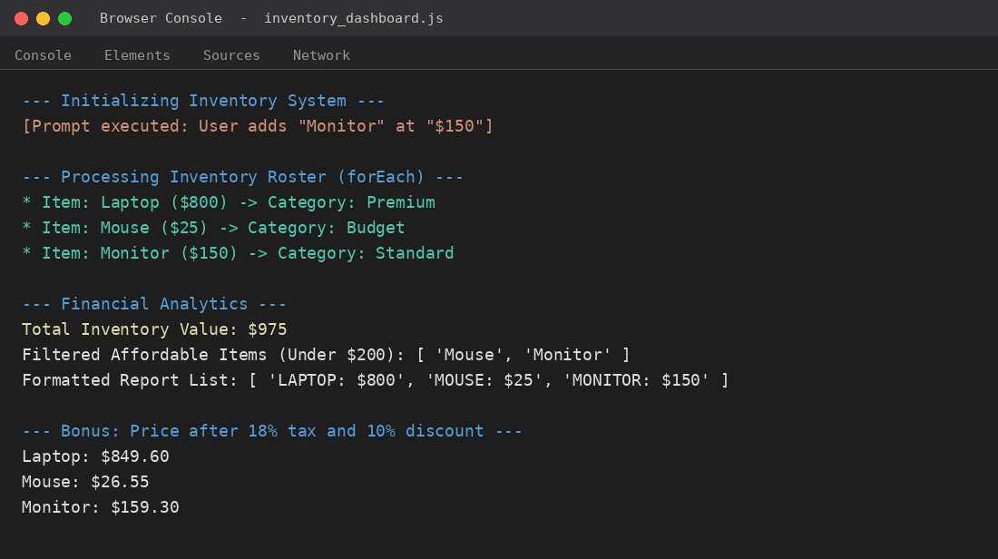
Figure: Inventory & Analytics Dashboard console output

